**Movie Booking Website + User Authentication**

**A MINI PROJECT REPORT**

***Submitted by***

**Group: G5**

**Jobanpreet Singh Gill, 2410990369**

**Kabirjeet Singh, 2410990370**

**Kanika Aggarwal, 2410990371**

***in partial fulfillment for the award of the degree of***

**BACHELEOR OF ENGINEERING**

***in***

CSE



**CHITKARA UNIVERSITY**

**CHANDIGARH-PATIALA NATIONAL HIGHWAY**

**RAJPURA (PATIALA) PUNJAB-140401 (INDIA)**

November, 2024

# Abstract

**Abstract: BookMySpot – A Responsive Movie Booking Website**

BookMySpot is a responsive online movie ticket booking platform developed to offer users a seamless experience for reserving movie tickets. The project incorporates both front-end and back-end technologies, ensuring a smooth and user-friendly interface.

For the front-end, we utilized **Bootstrap**, a widely-used CSS framework known for its powerful responsiveness and extensive built-in classes. Bootstrap simplifies the styling process by providing predefined classes for elements such as padding, margins, and layout designs. This allowed us to avoid the need for custom CSS, ensuring consistency and faster development of a responsive layout that works across various devices.

On the back-end, we employed the **Flask** web framework, which is well-suited for small to medium-sized projects due to its lightweight structure and simplicity. Flask is used to manage the website’s routing and server-side functionality. By defining routes and views, we were able to associate specific URLs with corresponding functions to handle user requests, such as movie selection and ticket booking. Additionally, **Jinja**, a templating engine integrated with Flask, enabled us to embed Python logic directly within the HTML, making it easier to render dynamic content based on user input and backend data.

Table of Contents

Abstract 2

1. Introduction 4

2. Problem Statement 4

3. Technical Details 4

4. Key Features 5

5. Project Advantages 5

6. Bonus Features 5

7. Results 5

List of References 6

# Introduction

In this project, we have created a responsive movie booking website named “BookMySpot” which will feature user login (authentication) and booking movie tickets online.

For the Front End, we have used **‘Bootstrap’** to provide the responsiveness to the website. Bootstrap features tons of features to the developers that makes building responsive websites easier. Bootstrap have built-in predefined classes for different attributes that we use in website building giving them predefined padding, margin, etc. Using Bootstrap in the project, has eliminated the use of CSS for the styling purposes.

We have also used **‘CSS’** for the front end at some places to give some extra functionality. Collectively, we have used both the *Bootstrap* and *CSS* in the project.

For the Back End, we have used Python Library called **‘Flask’** for creating the website’s routes/ views and also the database server. Flask is best for the small sized projects as it is light weight and is easy to use. Routes/ Views are the technique used to map the specific URL with the associated function intended to perform some task. We have also used **‘Jinja’** to add some of the python logic to the html document.

# Problem Statement

With the increasing popularity of online services, traditional methods of booking movie tickets—such as in-person purchases or phone reservations—have become outdated and inefficient. Users seek a more convenient, accessible, and responsive way to book movie tickets online across various devices. However, many existing online platforms are either typical to use, lack responsiveness on mobile devices, or do not provide a streamlined user experience, especially for smaller movie theaters or businesses with limited resources. There is a need for a lightweight, responsive, and user-friendly online movie ticket booking platform that ensures a seamless experience for users while allowing cinema owners to efficiently manage bookings. This platform should provide users with essential features such as secure login, easy navigation, and mobile responsiveness, all while being simple enough for small-sized businesses to adopt without the overhead of complex systems.

# Technical Details

The **BookMySpot** movie booking website leverages modern web technologies to deliver a responsive, efficient, and user-friendly experience. The front-end is built using **Bootstrap**, a widely adopted CSS framework known for its rich set of features that simplify web development. Bootstrap provides predefined classes for managing layout, padding, margins, and grid systems, which makes it easy to ensure responsiveness across various devices without writing extensive custom CSS. This ensures that the website is fully optimized for mobile and desktop users alike. (W3Schools.com, n.d.)

On the back-end, the website is powered by **Flask**, a lightweight and flexible Python web framework ideal for small- to medium-sized projects. Flask facilitates the creation of website routes and views, mapping URLs to specific functions responsible for handling tasks such as user authentication, movie selection, and ticket booking. Flask’s simplicity and ease of use make it a perfect choice for this project, allowing for rapid development without sacrificing functionality.

Additionally, the project incorporates **Jinja**, a templating engine that seamlessly integrates Python code within HTML templates. This enables dynamic content rendering, allowing personalized responses for users based on their input and real-time database interactions. The combination of Bootstrap, Flask, and Jinja ensures that the platform is both responsive and dynamically interactive, providing a smooth user experience while managing back-end logic and data handling effectively. (Tech With Tim, 2021)

We have also made our website online so that it can be accessed on any device anytime. Here is the link for the website: <https://bookmyspot.onrender.com/>

# Key Features

Some of the key features of the Project are:

* User Authentication
* Forgot Password with OTP verification
* Sign-up/ Login
* Password Encryption
* Backend Server Communication
* Responsive Design

# Project Advantages

The BookMySpot movie booking website offers significant advantages for users and cinema owners alike. Its responsive design ensures a seamless experience across devices, enhancing accessibility and convenience. The combination of Bootstrap and Flask allows for rapid development and easy maintenance, making it ideal for small cinemas with limited resources. User authentication enhances security, ensuring safe transactions. Additionally, the platform’s intuitive navigation simplifies the booking process, reducing the time and effort required for users. Overall, BookMySpot streamlines online ticket booking, providing a user-friendly solution that meets the evolving needs of modern moviegoers and cinema operators.

# Bonus Features

"Forgot Password" functionality, Email Confirmation message after successful booking of the movie. We have also added the search movie functionality by connecting an API with the website that shows the results about the searched moive.

# Results

The BookMySpot movie booking website successfully addresses the growing demand for a modern online ticketing solution. By leveraging Bootstrap for responsive design and Flask for backend functionality, the platform delivers a smooth user experience across all devices. Users can easily log in, browse movies, and book tickets securely, enhancing customer satisfaction. The integration of Jinja allows for dynamic content, providing personalized experiences based on user input. With its user-friendly interface and efficient management tools, BookMySpot empowers small cinemas to streamline operations and improve customer engagement, ultimately contributing to a more accessible and efficient movie booking process.

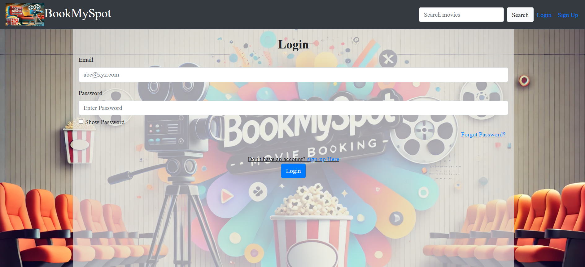

Login Page

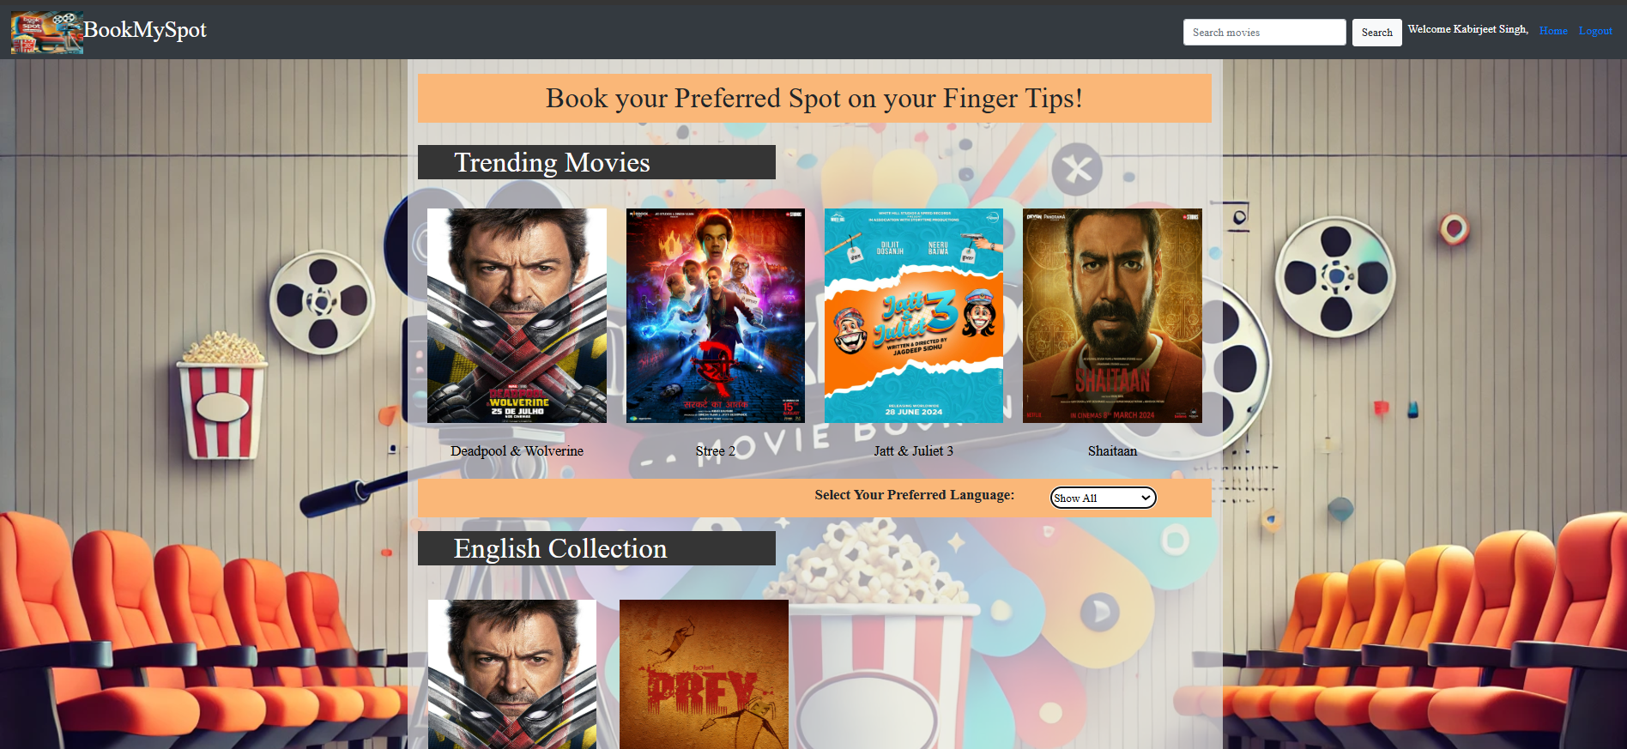

Home Page

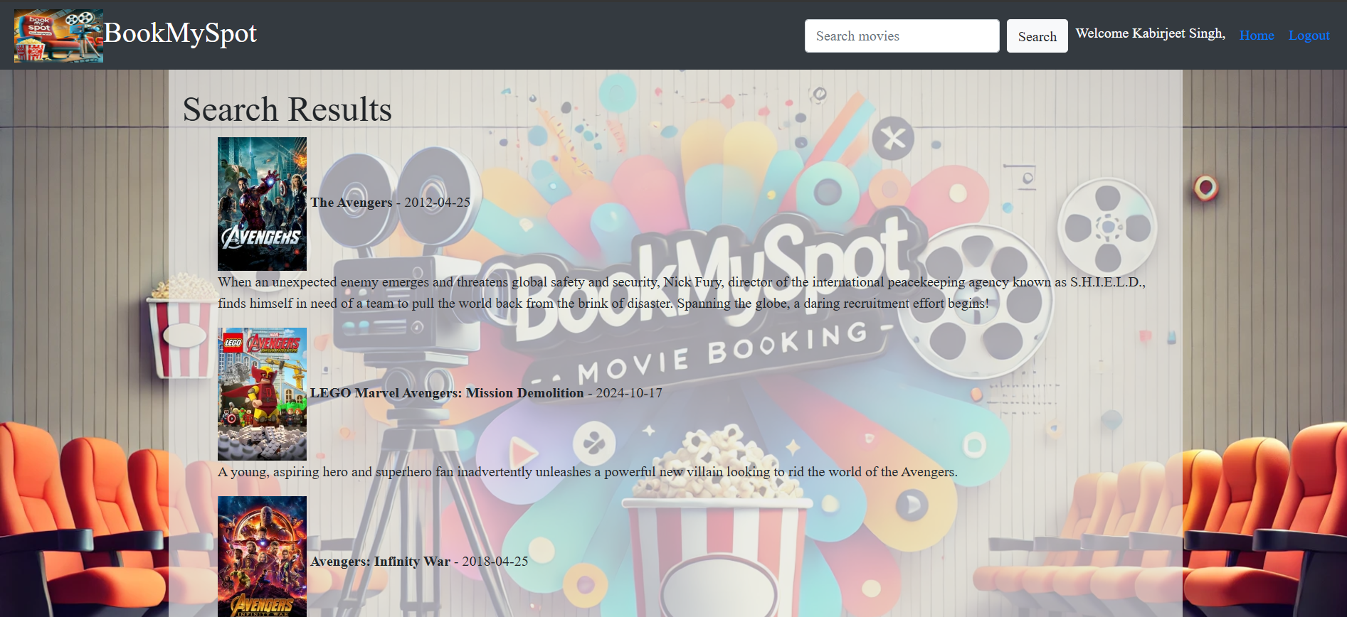

Movie Search Result Page

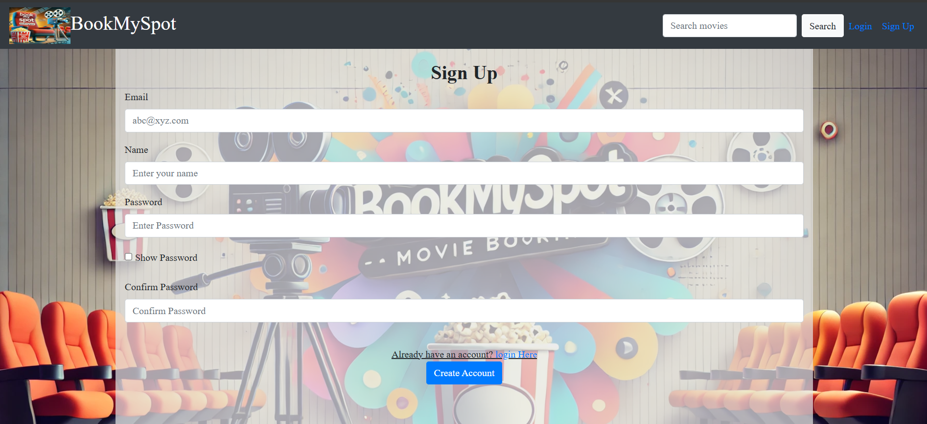

Sign-up Page

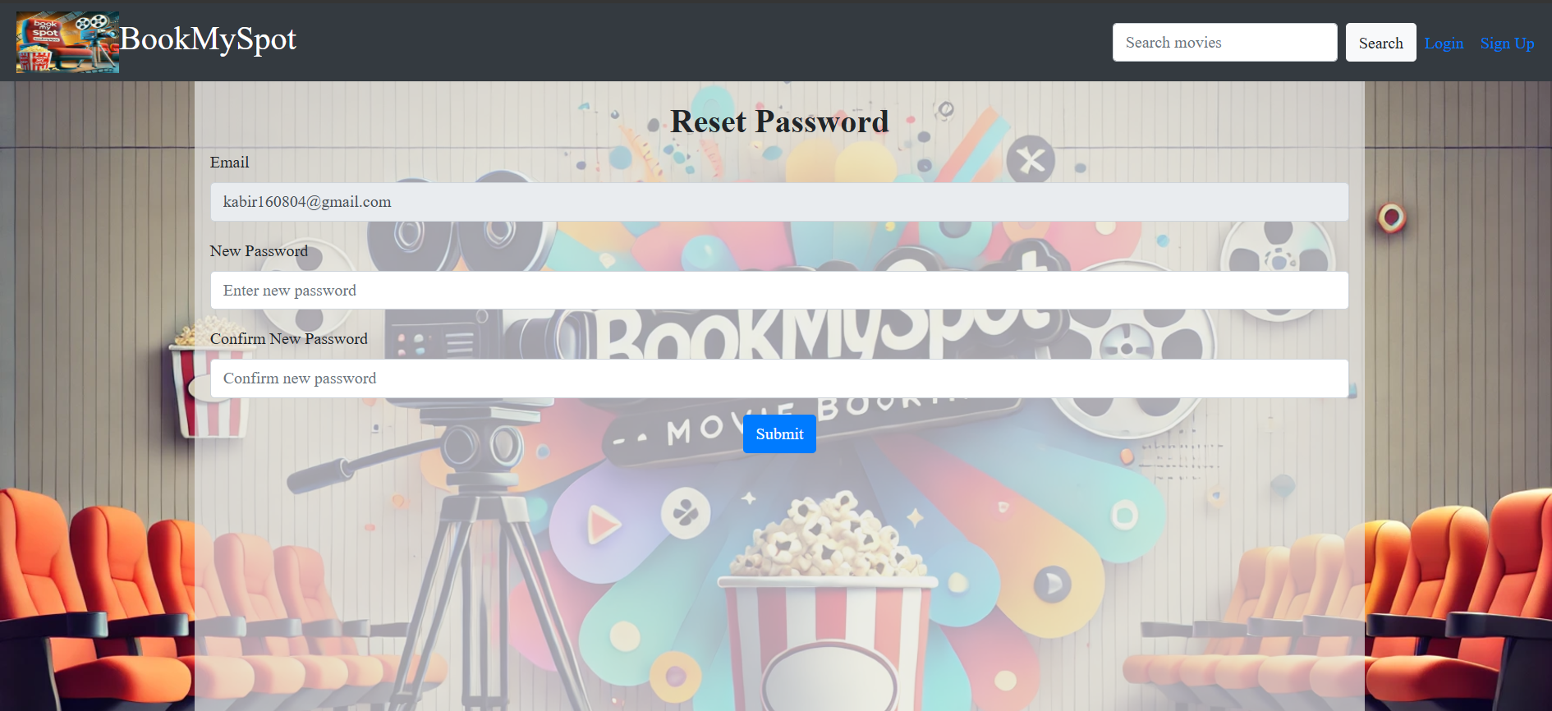

Reset password Page

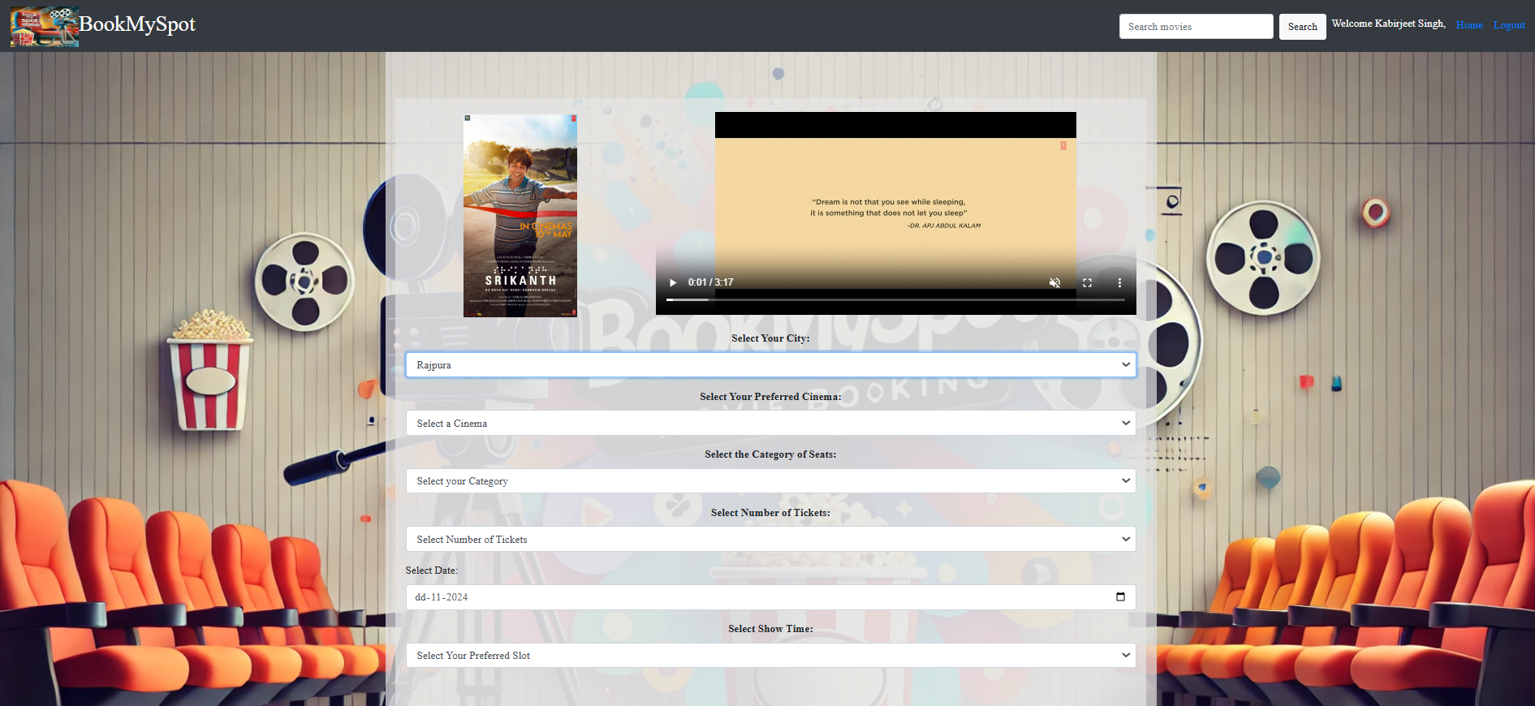

Movie Booking Page

# List of References

Tech With Tim. (2021, February 1). *Python website full tutorial - flask, authentication, databases & more* [Video]. YouTube. <https://www.youtube.com/watch?v=dam0GPOAvVI>

Ved The Master. (2021, August 10). *How to upload files/folders/projects on github | Upload Project folder on github (Simple Way)* [Video]. YouTube. <https://www.youtube.com/watch?v=eGaImwD8fPQ>

*W3Schools.com*. (n.d.). <https://www.w3schools.com/bootstrap/bootstrap_ref_all_classes.asp>